INTRODUCTION TO DBMS

Write SQL query to solve the problem given below Consider a database containing two tables named as Customer and Salesman For this you need to create a Customer table In Customer table attributes are customer id, customer name, city, grade and salesman id

Table : Customer

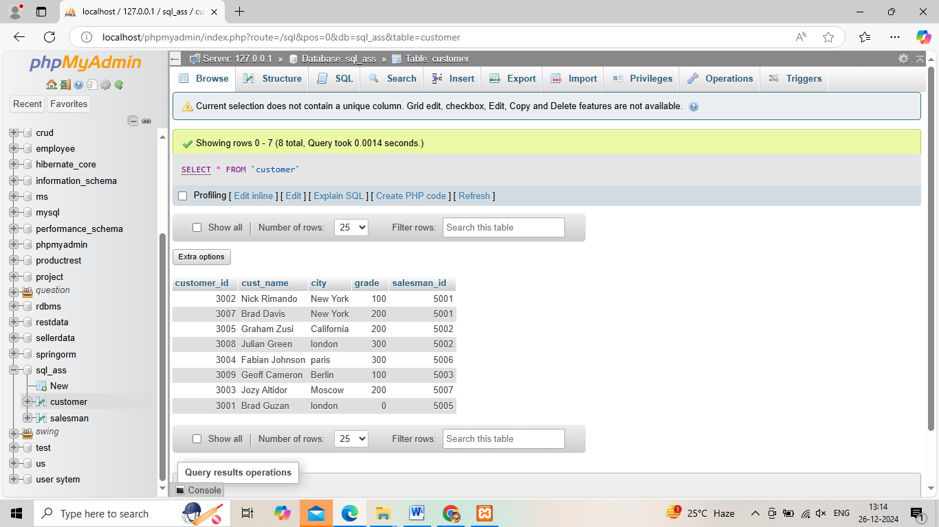

Table: Salesman

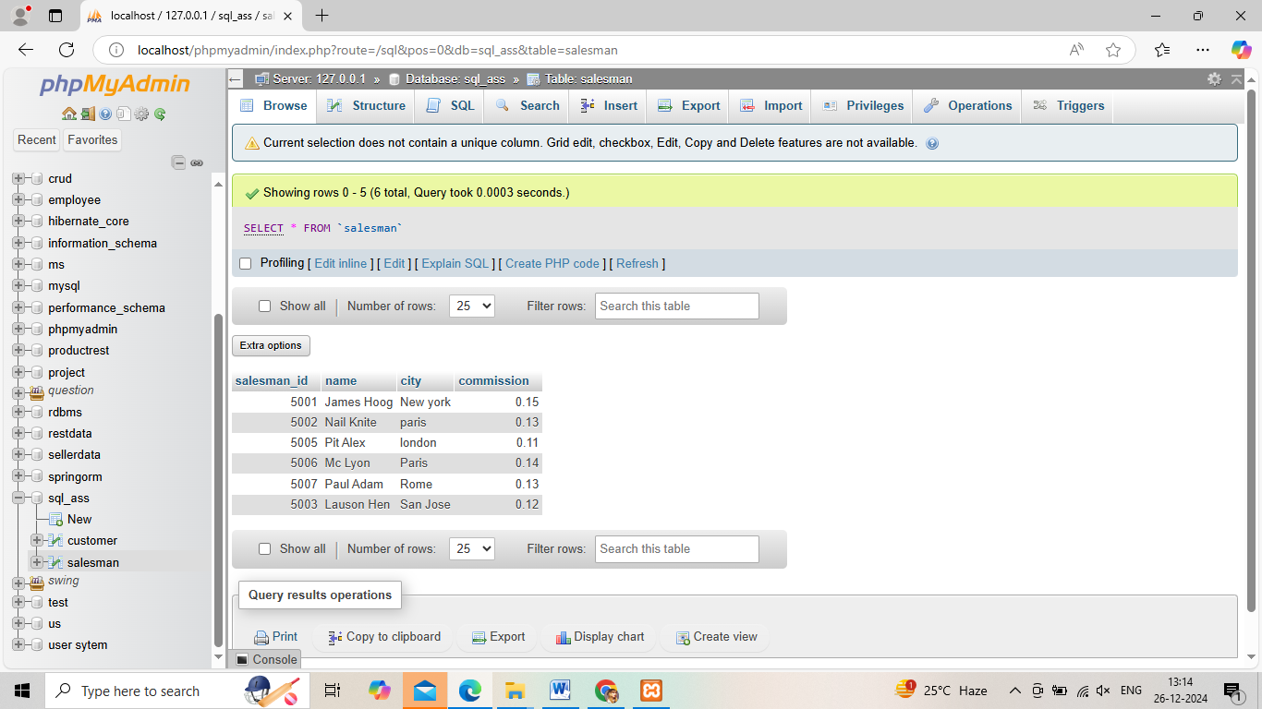

From the above given tables write a SQL query to find the salesperson(s) and the customer(s) represented here. Return the Customer Name, City, Salesman, commission.

